Jed’s Mail Test Tool

Testing html emails as part of a complex workflow is extremely hard for the testers because the testers only have a few options that maybe undesirable for the following reasons. The product out of the box allows testers can redirect the messages to a shared mailbox but this method can be hard for the tester to validate the message went to the correct recipient. This method also assumes the client allow dev/qa systems to send to the production smtp server. The other option is sending the results to a text file but this can also be an issue because it's hard for many testers to be able to read and validate the results especially with html content.

This plugin provides an option for developers and testers that is a simple plugin install. With this plugin you are launching a smtp listener on the IIQ box on port 8021. Any messages received on this port will be added to the plugin database. These email messages can be viewed in the product UI where the html will be rendered including the email address the message would have been sent to is displayed as a sudo inbox. This allows developers and testers to run any process in a dev system without any concerns of sending real emails or missing a key formatting issue. It also allows product specialist to demo to business users all the content in a way that adds confidence to the process.

# Install

Upload the zip file to the plugin page.

Log out and Login again.

**Install issues with my-sql**

If you get an error such as sailpoint.tools.GeneralException: Cannot create PoolableConnectionFactory (The server time zone value 'CDT' is unrecognized or represents more than one time zone. You must configure either the server or JDBC driver (via the serverTimezone configuration property) to use a more specifc time zone value if you want to utilize time zone support.)

Add the following entry to your iiq.property for the plugin database.

&serverTimezone=UTC

# Validate the Install

From the console run a quick test to make sure everything is working as it should



From the UI click the button next to home  and then click Email Validation

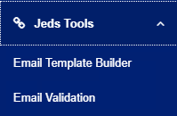

You should see your test message sent from the console

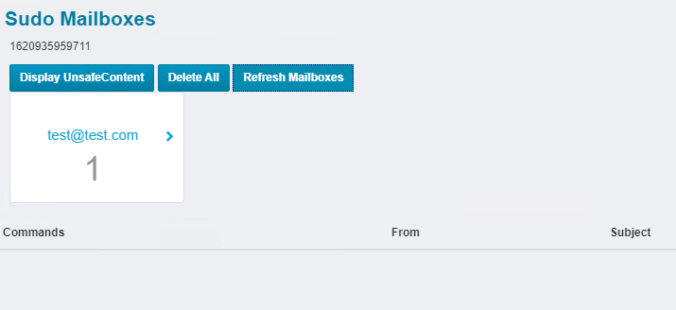

# Daily Use

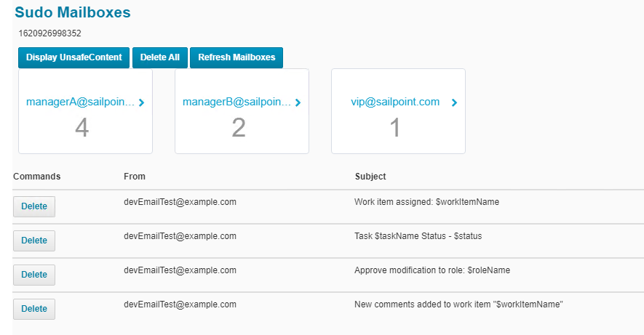

## Display UnsafeContent.

This button will display all content in the email template. By default the html is cleaned for CSS and links by angular. But this means html CSS code will also be removed. Once you click this button an Iframe will be opened that will render the message without any angular protections. This is the only real way to know how the message will look in user’s inbox.

## Delete All

Removes all messages from the plugin database. It’s a great option to use before doing a demo.

## Refresh Mailbox

Pulls the list of mailboxes and message count

Just click on any of the email tiles and the emails will show the subject, from and time received. Click on any of the rows and it will load the body of the message.